Sudan Recovery Map

By

Khalid Tajelsir
Mohamed Abdelkhalig

Submitted in Partial Fulfillment of the Requirements for the Degree of
Bachelor of Science in Computer Science
at
Future University
July/2025

Project Thesis Supervisor
(Razan Haydar)

The Final Project Course Adviser
(Dr. Zeinab M. Sedahmed)

©2025 Khalid, Mohammed. All Rights Reserved
ACKNOWLEDGMENT
We would like to express our sincere gratitude to our supervisor, Dr. Razan Hayder, for her continuous guidance, encouragement, and valuable insights throughout the development of this project.
We also extend our heartfelt thanks to the Dean, Dr. Zeinb, for her support and inspiration, which greatly contributed to the successful completion of our work.
Finally, we are grateful to our families, colleagues, and everyone who provided assistance and motivation during this journey.

TABLE OF CONTENTS

LIST OF FIGURES V
LIST OF ABBREVIATIONS VI
ABSTRACT VII
Chapter 1 1
INTRODUCTION 1
1.1 Background of the Study 1
1.2 Significance of the Study 2
1.3 Objectives 2
1.4 Scope and Delimitations 2
1.5 Conceptual Framework 3
1.6 Definition of Terms 4
Chapter 2 6
REVIEW OF RELATED LITERATURE 6
2.1 Humanitarian Mapping Tools 6
2.2 AI in Satellite Image Analysis 6
2.3 Community Platforms for Disaster Recovery 7
2.4 Geospatial Platforms in Post-Conflict Reconstruction 7
2.5 AI-Based Damage Assessment in Crisis Zones 8
2.6 Participatory Technology and Civic Platforms 8
2.7 Crisis Information Management Systems 8
2.8 Remote Sensing and Change Detection 9
2.9 Digital Platforms for Transparency and Accountability 9
2.10 Digital Platforms for Post-Disaster Urban Recovery 10
2.11 Smart Agriculture and Food Security Monitoring in Post-Conflict Zones 10
2.12 Community-Based Health and Education Monitoring Platforms 10
2.13 AI-Enhanced Infrastructure Monitoring 11
2.14 Disaster Risk and Early Warning Systems 11
2.15 Participatory Mapping for Social Cohesion 11
2.16 Mobile Crowdsourcing for Local Needs Assessment 12
Chapter 3 14
METHODOLOGY 14
1. Introduction 14
2. Methodological Approach 14
The model steps: 14
3.3.1. Development Tools and Technologies 14
3.3.2. Development Process Steps 15
15
3.3.3. Requirements Gathering 17
3.3.4. Analysis 17
3.3.4.1. Proposed system description: 18
3.3.4.2. Use Case Diagram: 18
• System Data Flow Diagrams (DFD) 20
3.3.4.3. Entity Relationship Diagram (ERD) 21
3.3.5. DESIGN 23
3.3.5.1. DESCRIPTION OF THE PROPOSED (NEW) SYSTEM 23
3.3.5.1.1. Abstract Language (Data, Process, Role, Rule) 23
Functional Requirements 23
Non-Functional Requirements 23
3.3.6. Modeling 23
3.3.6.1. PROCESS: Activity & Sequence 23
e) ROLE: Use Case 23
f) CONSTRAINTS / RULE 24
g) SYSTEM ARCHITECTURE, APPLICATION ARCHITECTURE 24
h) SYSTEM / SOFTWARE SPECIFICATION 24
3.3.7. SYSTEM COMPONENTS 24
3.3.7.1. Interface / input & output design 24
3.3.7.2. Scenario / Order (Storyboard) 27
3.3.8. Database Design 28
3.3.8.1. PHYSICAL DESIGN (Physical Storage) 28
3.3.8.2. Database View (Dummy Data) : 28
3.3.8.3. Tools (Dataset Manipulation Steps) 29
3.3.9. Algorithms (Flow Chart): Optional 29
3.3.10. Coding: Page (1–3) 29
3.3.11. Testing: Page (1–3) 30
3.3.12. User manual 30

LIST OF FIGURES

Figure 1 Conceptual Framework 3
Figure 2: Development Process Steps 2
Figure 3: Use Case Diagram 6
Figure 4: level 0 DFD 7
Figure 5 level 1 DFD 8
Figure 6 Entity Relationship Diagram 9
Figure 7 Home Page Screen 12
Figure 8 Citizen Report Form 13
Figure 9 Main Map Screen (1) 13
Figure 10 Main Map Screen (2) 14
Figure 11 Login and Register 14

LIST OF ABBREVIATIONS

- ERD – Entity Relationship Diagram
- UAT – User Acceptance Testing
- DFD – Data Flow Diagram
- UI/UX – User Interface / User Experience
- CNN – Convolutional Neural Network
- JWT – JSON Web Token
- NGO – Non-Governmental Organization
- API – Application Programming Interface
- HTML – HyperText Markup Language
- CSS – Cascading Style Sheets
- AI – Artificial Intelligence
- REST – Representational State Transfer
- ESA – European Space Agency
- NASA – National Aeronautics and Space Administration

ABSTRACT

This project aims to support Sudan’s post-war recovery through a web application that provides an interactive platform for mapping affected areas, displaying AI-analyzed satellite images, identifying available services like electricity and water, collecting citizen input, and helping NGOs and government agencies prioritize recovery efforts. It also enables citizens to vote on needs, share local initiatives, and contribute to a living digital archive. The system will enhance decision-making, promote transparency, and foster community participation.

Keywords: Sudan, post-war, AI mapping, citizen engagement, recovery platform

المستخلص
يهدف هذا المشروع إلى دعم جهود التعافي بعد الحرب في السودان من خلال تطوير تطبيق ويب يُوفر منصة تفاعلية لرسم خريطة للمناطق المتضررة، وعرض صور الأقمار الصناعية التي تم تحليلها باستخدام الذكاء الاصطناعي، وتحديد الخدمات المتوفرة مثل الكهرباء والمياه، بالإضافة إلى جمع مدخلات المواطنين ومساعدة المنظمات الإنسانية والجهات الحكومية في تحديد أولويات التعافي. كما يُتيح النظام للمواطنين التصويت على الاحتياجات، ومشاركة المبادرات المحلية، والمساهمة في أرشيف رقمي حي يُوثق جهود التعافي.

الكلمات المفتاحية: السودان، ما بعد الحرب، رسم الخرائط بالذكاء الاصطناعي، مشاركة المواطنين، منصة التعافي

CHAPTER ONE
INTRODUCTION

Chapter 1

INTRODUCTION

Sudan has entered a critical phase of post-conflict recovery. After suffering widespread destruction, particularly in major cities such as Khartoum, there is a growing demand for innovative tools that can support national reconstruction. This chapter introduces the motivation behind the project, provides background information, explains the scope, and outlines the significance of developing a web-based platform that leverages AI and public engagement to map and assist in Sudan’s recovery process.
- Background of the Study
Sudan has long been challenged by political instability, but the recent war that erupted in 2023 brought unprecedented levels of destruction to the nation’s infrastructure, economy, and social systems. Major cities, particularly Khartoum, faced severe damage to essential services such as electricity, water, transportation, education, and healthcare. The war has displaced millions, interrupted communication networks, and left government institutions struggling to assess and address the scale of the devastation.
In global post-conflict scenarios, technological solutions—especially web platforms powered by satellite imagery and artificial intelligence—have proven valuable in accelerating recovery and enabling more effective aid distribution. Countries like Ukraine and Syria have implemented mapping tools to visualize war damage, inform reconstruction, and engage citizens in reporting on-ground conditions. Unfortunately, Sudan lacks any centralized or digital platform capable of tracking recovery progress, identifying community needs, or organizing collaborative rebuilding efforts.
The lack of real-time information on infrastructure status and local needs not only delays humanitarian response but also disconnects affected citizens from participating in the national recovery process. At the same time, many organizations and volunteers are willing to contribute but are hindered by limited access to verified data or communication platforms.
This project, therefore, emerges from the urgent necessity to provide a digital tool that bridges this gap—a platform that collects and visualizes recovery data, facilitates community input, and guides decision-making for both government bodies and NGOs. It seeks to leverage artificial intelligence and user interaction to deliver a meaningful contribution to Sudan’s long-term recovery and social resilience.
- Significance of the Study
This project provides a vital platform for recovery and redevelopment. It serves multiple stakeholders including the Sudanese government, NGOs, and local citizens. It enables visualization of damage and restored areas, provides real-time service availability updates, and fosters grassroots involvement in rebuilding efforts. In doing so, the platform supports transparency, coordination, and informed decision-making.
- Objectives
Main Objective:
To develop a technological platform that supports Sudan’s recovery through mapping, data collection, and community engagement.
Specific Objectives:
- To build an interactive map displaying affected and restored areas.
- To apply AI to satellite images for pre- and post-war comparisons.
- To show available services (electricity, water) via the interactive map.
- To allow citizens to report needs and share local recovery initiatives.
- To create a real-time feedback loop between citizens and aid planners.
- Scope and Delimitations
Scope: This project targets post-war zones in Sudan. It includes a web-based system with AIsatellite analysis, map-based visualization, citizen reports, and public voting on needs.

Delimitations:
- The platform may not cover all rural zones due to satellite imagery limitations.
- Reliance on available AI models may affect image interpretation accuracy.
- User-submitted data may vary in reliability.
- Conceptual Framework
The data will be collected from satellite images and citizen input. Then, it will be analyzed using AI to detect damaged and recovered areas. Finally, the results will be presented on an interactive map to support recovery planning and public participation.
Input: Satellite images, user reports, service provider updates

Process: AI analysis, data categorization, geospatial mapping

Output: Interactive recovery map, visual analytics, reports.

Figure 1 Conceptual Framework

- Definition of Terms
- - Recovery Map: A digital map highlighting damaged and restored areas
- Citizen Reporting: Submissions by users about local conditions
- Satellite Imagery: Space-based photos used to visualize terrain changes
- Post-war Platform: A system built to aid reconstruction after conflict

CHAPTER TWO
REVIEW OF RELATED LITERATURE

Chapter 2

REVIEW OF RELATED LITERATURE
- Humanitarian Mapping Tools
Humanitarian Mapping and Post-Conflict Recovery Platforms In recent years, digital mapping platforms have become critical tools in disaster and post-conflict recovery. Projects like Humanitarian OpenStreetMap (HOT), CrisisMappers, and UN OCHA's ReliefWeb Map Centre have demonstrated the power of crowdsourced and satellite-assisted mapping. These platforms allow users to report incidents, map damaged infrastructure, and visualize access to services in near real-time.
For example, during the 2010 Haiti earthquake, OpenStreetMap was extensively used to map affected areas and guide relief efforts. In Ukraine, satellite imaging and geospatial analysis are used to assess war damage and prioritize reconstruction efforts. Similarly, in Syria, organizations utilized satellite data to monitor the impact of airstrikes and assess the condition of hospitals and schools.
These tools, however, often rely heavily on either satellite input or volunteer contributions, which can limit their accuracy and coverage. Moreover, they are typically focused on short-term crisis management rather than long-term recovery and citizen engagement, which is a key focus of our proposed platform.
- AI in Satellite Image Analysis
Artificial Intelligence in Satellite Image Analysis AI has increasingly been applied to the analysis of satellite imagery, especially in identifying damage from natural disasters and conflicts. Machine learning models can now detect changes in infrastructure, identify temporary shelters, and assess urban growth. Tools such as Google Earth Engine and open-source libraries like TensorFlow have democratized access to these capabilities.
One study by the Stanford Sustainability Lab demonstrated how convolutional neural networks (CNNs) could be trained to identify poverty levels by analyzing satellite images. Another example is the use of AI to estimate flood extent and fire damage, significantly improving the response time and accuracy compared to manual assessments.
In a war-torn country like Sudan, AI-powered satellite analysis can offer an unbiased, rapid, and wide-reaching way to assess the destruction, track rebuilding progress, and inform strategic planning. The proposed system seeks to integrate this technology in a user-accessible platform that not only visualizes data but empowers users to interact with it.
- Community Platforms for Disaster Recovery
Community Engagement and Participatory Platforms Community involvement in crisis management is essential for building trust, identifying local priorities, and enhancing recovery outcomes. Platforms like Ushahidi in Kenya allowed users to report incidents through SMS, web, and mobile apps, which were then visualized on a map. This model was successfully used during political unrest and natural disasters in several countries.
Furthermore, platforms like Map Kibera (Kenya), FixMyStreet (UK), and SeeClickFix (USA) show how local input can be turned into actionable data for municipal services and development projects. These platforms demonstrate the benefits of giving citizens a voice and responsibility in shaping their recovery and development landscape.
Our proposed platform builds on these concepts by combining AI mapping with citizen input and voting mechanisms to prioritize services and interventions. By enabling citizens to directly contribute and see the impact of their contributions, the platform fosters a sense of ownership and collective responsibility for national recovery.

Geospatial Platforms in Post-Conflict Reconstruction
Geospatial technologies have become essential tools in post-conflict reconstruction planning. Platforms such as ArcGIS Online, Google Earth Engine, and Mapbox enable governments and organizations to visualize damage, assess needs, and plan rebuilding in real-time. In post-war Iraq and Afghanistan, the World Bank used satellite mapping to monitor school reconstruction and public infrastructure development. These tools also help in comparing pre- and post-conflict conditions to guide budget allocation. However, most of these systems lack integration with citizen participation and real-time feedback, which our proposed platform aims to address by combining geospatial mapping with crowdsourced data and AI-driven analysis.

AI-Based Damage Assessment in Crisis Zones
Recent studies have shown the effectiveness of artificial intelligence in analyzing satellite imagery for disaster response. For example, the xView2 Challenge by the Defense Innovation Unit encouraged the development of AI models capable of detecting buildings damaged by natural disasters using pre- and post-event satellite images. Similarly, research conducted by the Stanford Sustainability Lab demonstrated how convolutional neural networks (CNNs) could be used to predict poverty levels by analyzing nighttime satellite imagery. These approaches show the potential of AI in extracting valuable insights from visual data. Yet, despite the growing use of AI, many platforms remain inaccessible to local populations or do not reflect on-the-ground realities — a challenge our system addresses by combining automated insights with citizen reports.

Participatory Technology and Civic Platforms
In many crisis-affected areas, participatory platforms have bridged the gap between authorities and citizens. The Ushahidi platform, originally developed in Kenya during political unrest, allowed individuals to report incidents via SMS, and the reports were displayed on an interactive map. This model has since been replicated globally in disaster zones, such as during the Haiti earthquake and the Syrian civil war. In the UK, FixMyStreet enabled residents to report infrastructure problems directly to municipal authorities. While these tools promote engagement, they typically lack AI integration or post-war focus. Our system expands on these efforts by empowering citizens not only to report but also to vote on needs, track recovery progress, and interact with real-time geospatial data.

Crisis Information Management Systems
Crisis Information Management Systems (CIMS) are platforms designed to aggregate and analyze data during emergencies. Examples include Sahana Eden, an open-source disaster management system used in countries like Haiti and the Philippines, which enables coordination between relief agencies, tracks missing persons, and monitors available resources. These systems demonstrate the importance of centralized, accessible information during humanitarian crises. However, they are often tailored to immediate response rather than long-term recovery, and they usually lack integration with AI and interactive maps. Our proposed platform addresses this by blending crisis management, real-time AI analysis, and post-war citizen feedback.

Remote Sensing and Change Detection
Remote sensing technologies, especially when combined with change detection algorithms, have been widely used to monitor urban expansion, deforestation, and conflict zones. Techniques like image differencing and normalized difference indices allow for automated detection of changes in landscapes. For example, during the Syrian conflict, remote sensing was used to monitor the destruction of cultural heritage sites. In Sudan’s context, this technology is particularly valuable due to limited ground access in many war-affected areas. Our platform incorporates this capability through AI-powered change detection applied to satellite imagery, allowing both government and citizens to track reconstruction progress over time.

Digital Platforms for Transparency and Accountability
Transparency and accountability are key pillars in post-conflict governance. Platforms like Open Government Data Portals and Open Contracting Platforms have been implemented in countries like Ukraine and Colombia to prevent corruption and misuse of resources during reconstruction. These systems publish real-time data on budgets, aid distribution, and project status. While not always interactive or citizen-centered, they reflect the global shift toward digital tools that ensure public oversight. Our system shares this vision by offering visual updates on recovery efforts, voting mechanisms, and a participatory archive of community input, promoting open and transparent development.

2.10 Digital Platforms for Post-Disaster Urban Recovery
Digital platforms have increasingly been used to accelerate urban recovery following natural disasters such as earthquakes, floods, and hurricanes. By integrating satellite imagery and artificial intelligence, these systems can automatically detect damaged infrastructure, collapsed bridges, and flooded neighborhoods. Examples include the use of geospatial platforms in disaster-hit areas to compare pre- and post-event conditions, providing decision-makers with reliable tools for planning and prioritization.
These platforms often feature AI-driven damage assessment and interactive maps that display recovery progress in real time. They also allow governments and humanitarian organizations to monitor restoration of essential services like electricity and water. However, many systems remain limited in citizen engagement, reducing opportunities for local communities to share their needs and priorities. Our proposed system builds on these approaches by combining automated change detection with participatory mapping and citizen reporting tools to create a more inclusive and transparent recovery process.

2.11 Smart Agriculture and Food Security Monitoring in Post-Conflict Zones
Food security is one of the most pressing challenges in post-conflict recovery, as wars and political instability often disrupt farming, irrigation, and supply chains. Remote sensing and AI-based agricultural monitoring have been applied in various contexts to track soil quality, crop yields, and vegetation health. For instance, machine learning models have been used to predict harvest outcomes and identify regions at risk of famine, while satellite imagery supports the detection of land degradation and water shortages.
Several projects have also incorporated community participation by enabling farmers to report local challenges such as pest infestations and irrigation breakdowns. These combined approaches help humanitarian agencies design targeted interventions. Nevertheless, most existing platforms are either research-focused or inaccessible to local farming communities. Our system addresses this gap by merging satellite-based monitoring with farmer-driven mobile reporting, ensuring that agricultural recovery efforts are both technologically advanced and locally grounded.

2.12 Community-Based Health and Education Monitoring Platforms
Health and education systems are among the most severely affected in post-conflict contexts, with hospitals, clinics, and schools frequently damaged or abandoned. Digital platforms have been introduced to monitor service availability and recovery in these sectors, often by aggregating data from government and NGO sources. For example, mobile applications and web platforms have been developed to crowdsource information about the operational status of schools and clinics, while AI analytics highlight priority areas lacking access to basic services.
Platforms such as these promote transparency and accountability by making information publicly accessible and actionable. They also empower citizens by allowing them to provide feedback and identify urgent needs. However, most existing systems are fragmented and lack mechanisms for sustained community engagement. Our proposed platform builds on these experiences by integrating citizen reports, government data, and NGO inputs into a unified dashboard, where residents can also vote on local priorities. This participatory approach ensures that recovery in health and education reflects the needs of vulnerable populations, especially women and children.
:

2.13 AI-Enhanced Infrastructure Monitoring
Post-conflict regions often suffer from severely damaged infrastructure, including roads, bridges, and public buildings. AI-based monitoring systems have been developed to analyze satellite imagery and drone data for detecting structural damage, estimating repair costs, and prioritizing interventions. Platforms in countries like Iraq and Syria have demonstrated that combining convolutional neural networks (CNNs) with geospatial mapping allows rapid identification of critical infrastructure needs.
These AI-driven approaches help decision-makers allocate resources efficiently while reducing reliance on slow ground surveys. However, existing systems often lack integration with citizen reporting, which limits community input in identifying urgent repairs. Our platform aims to bridge this gap by combining AI analysis with citizen-submitted reports, creating a more participatory and data-driven infrastructure recovery process.

2.14 Disaster Risk and Early Warning Systems
Early warning and risk assessment platforms are crucial for preventing further damage in post-conflict regions. Systems like the Integrated Food Security Phase Classification (IPC) and the Global Disaster Alert and Coordination System (GDACS) use satellite data, weather models, and crowdsourced inputs to forecast risks such as floods, droughts, or disease outbreaks.
By incorporating AI and citizen data, these systems can improve the timeliness and accuracy of alerts, enabling communities to prepare for or mitigate potential hazards. In Sudan, such integrated platforms can support both humanitarian organizations and local populations by providing real-time situational awareness and reducing vulnerability during the recovery phase.

2.15 Participatory Mapping for Social Cohesion
Post-conflict recovery is not only about physical reconstruction but also about rebuilding trust and social cohesion. Participatory mapping initiatives allow local communities to document cultural, social, and economic assets, fostering inclusion and empowerment. Platforms such as Map Kibera (Kenya) and Ushahidi (Kenya) have been used to identify community resources, highlight gaps, and engage citizens in decision-making processes.
These methods have shown that mapping social and cultural assets can strengthen community ties and improve the relevance of reconstruction efforts. Integrating such participatory mapping into AI-enhanced recovery platforms ensures that reconstruction aligns with local needs and promotes long-term social resilience.

2.16 Mobile Crowdsourcing for Local Needs Assessment
Mobile crowdsourcing applications have been widely used in disaster response to collect real-time information on local needs and resource availability. Examples include platforms that allow citizens to report on water shortages, medical supply gaps, or electricity outages. These tools enhance situational awareness for NGOs and government agencies.
However, many existing applications operate in isolation, limiting their ability to provide comprehensive overviews of recovery progress. Our proposed system addresses this by integrating mobile crowdsourced data with satellite imagery, AI analysis, and centralized dashboards, enabling holistic monitoring and rapid prioritization of interventions.

CHAPTER THREE

Chapter 3

METHODOLOGY
- Introduction
The development of this project followed the Agile software development model. Agile is an iterative and incremental approach that emphasizes flexibility, user feedback, and continuous improvement. It allows the project team to work in short development cycles called sprints, each delivering a functional part of the system. This model was chosen due to its adaptability to change and its ability to involve stakeholders throughout the development process, making it suitable for a dynamic and user-centered platform like the one proposed for Sudan’s post-war recovery.

- Methodological Approach
The system will be developed using the Agile development method to ensure iterative feedback and improvement.

The model steps:

Development Tools and Technologies
The proposed platform is being developed using modern web technologies. For the front-end, we use HTML, CSS, Bootstrap, and React.js to create a responsive and dynamic user interface. We also utilize Leaflet.js and Mapbox to build an interactive map that displays affected and recovered areas in real time. On the back-end, we use PHP with the Laravel framework to handle server-side logic and API development. The database is managed using MySQL. This technology stack was chosen for its scalability, community support, and suitability for building robust, data-driven web applications.

Development Process Steps
The development of the Sudan Recovery Map platform followed the Agile methodology, which is characterized by iterative development, continuous user feedback, and incremental improvement. The Agile cycle consists of seven main steps, each of which played a significant role in shaping the system.
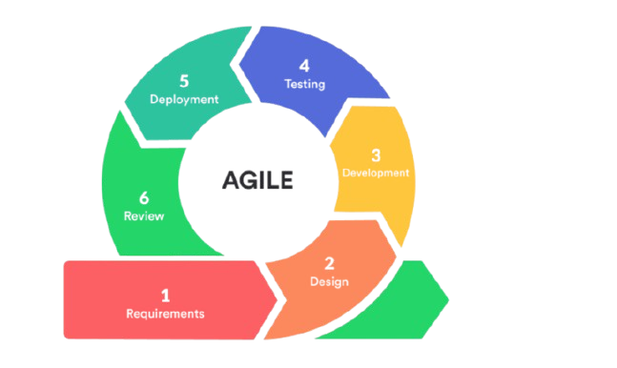
Figure 2: Development Process Steps

Requirements
In this phase, the team collected requirements from potential users, including displaced citizens, NGOs, and government agencies. The goal was to identify the core functionalities such as the interactive map, AI-based satellite image analysis, citizen reporting, service availability tracking, and voting mechanisms. Requirements were documented and prioritized to guide subsequent development steps.

Design
The design phase focused on creating system models and prototypes. Tools such as Use Case Diagrams, Entity-Relationship Diagrams (ERD), and Data Flow Diagrams (DFD) were employed to visualize data flow and user interactions. At this stage, the user interface (UI/UX) was also designed to ensure accessibility and simplicity, enabling both technical and non-technical users to navigate the system.

Development
During this stage, the coding process was carried out. The front-end was developed using HTML, CSS, Bootstrap, and React.js, while Leaflet.js and Mapbox were integrated to implement the interactive mapping features. On the back-end, PHP with the Laravel framework was used to handle logic, authentication, and API development. MySQL was employed for database management. For AI integration, Python libraries such as TensorFlow and OpenCV were utilized for satellite image change detection and damage assessment.

Testing
Testing was a critical phase to ensure the system functioned as expected. Both functional testing and usability testing were conducted to verify features such as map rendering, AI analysis accuracy, citizen reporting, and voting. User Acceptance Testing (UAT) sessions with sample users (citizens and NGO staff) provided insights into real-world performance and identified areas for improvement.

Deployment
After successful testing, the platform was deployed on a cloud-based hosting service to make it publicly accessible. This stage included configuring servers, setting up databases, and ensuring scalability for handling large datasets from satellite images and user reports.

Review
Once deployed, feedback from stakeholders was systematically reviewed. The review process allowed the project team to assess system performance, identify usability challenges, and evaluate whether the platform effectively supported recovery planning and citizen engagement

    - Requirements Gathering
Data will be collected from: - Open-source satellite datasets - User feedback via forms and reports - Surveys and interviews with displaced citizens
Functional Requirements:
- Interactive map with AI-labeled satellite images
- Real-time citizen reporting system
- Admin panel for NGOs and government agencies
- Voting and feedback system for prioritizing services
- Development Tools and Technologies The system is built using modern web technologies:
- Front-End: HTML, CSS, Bootstrap, React.js, Leaflet.js, Mapbox
- Back-End: PHP (Laravel Framework), RESTful APIs
- Database: MySQL for relational data management
- AI Tools: Python-based image analysis using TensorFlow and OpenCV libraries for change detection in satellite imagery

    - Analysis
Current system description: There is no centralized system available; recovery data is fragmented or non-existent. Existing systems used by aid groups are isolated and lack public visibility.
      - Proposed system description:
- Central web interface with mapping capabilities - AI-based pre/post comparison of satellite imagery - Citizen reporting system for local needs - Voting mechanism for service prioritization - Administrator dashboards for NGO/government use

Use Case Diagram:
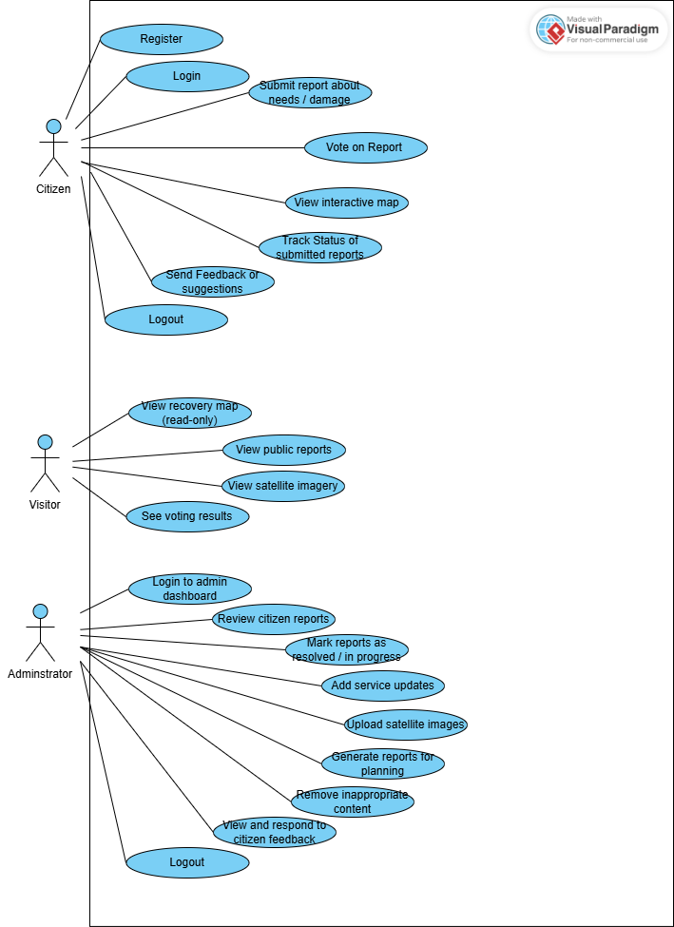
Figure 3: Use Case Diagram

System Data Flow Diagrams (DFD)
To better illustrate the flow of data in the proposed Sudan Recovery Map platform, Data Flow Diagrams were developed.
• Figure 4 shows the Level 0 DFD (Context Diagram), which highlights the interaction between the system and external entities such as citizens, NGOs, government agencies, and satellite data providers.
•
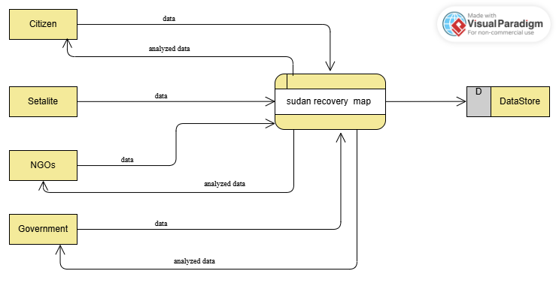
Figure 4: level 0 DFD

Figure 5 shows the Level 1 DFD, which breaks down the internal processes of the system, including user management, report handling, AI-powered analysis, voting and feedback, and interactive mapping. These processes interact with different databases to ensure data storage,
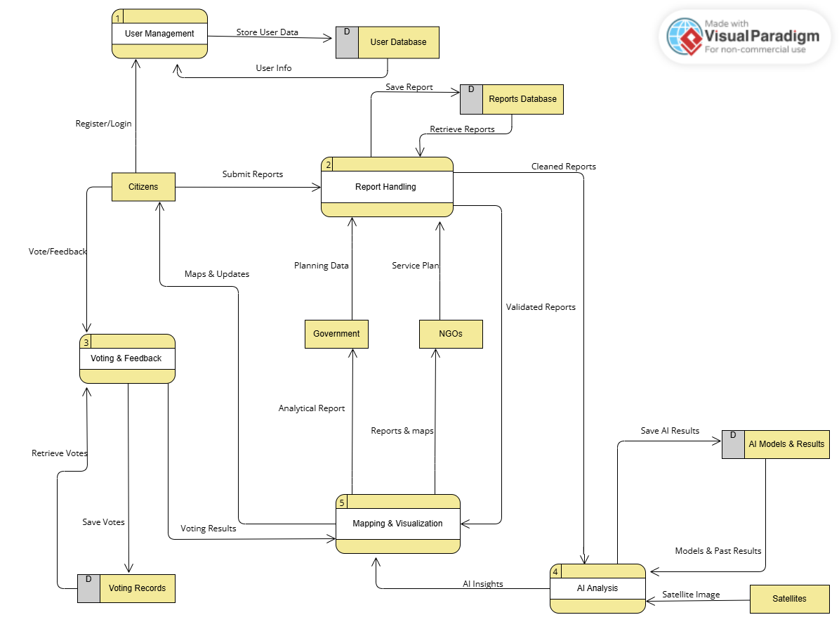
Figure 5 level 1 DFD

Entity Relationship Diagram (ERD)

The ERD illustrates the main entities of the Sudan Recovery Map system and their relationships.
User: Represents system users, including citizens, NGOs, and administrators. Each user has a unique ID, name, email, password, and role.
Report: Stores incident or recovery reports submitted by users. Each report includes title, description, location, timestamp, and status.
Image: Linked to reports, images may be satellite-based or user-submitted, with AI-detected damage information.
Vote: Allows users to upvote or downvote reports to prioritize needs and recovery services.
Service: Represents essential services (e.g., electricity, water) with their details.
Feedback: Enables users to provide system-related feedback and suggestions.

Relationships:
- A user can submit multiple reports, votes, and feedback entries.
- A report can have multiple related images and votes.
- Services are independent entities that can be referenced in recovery planning.
This diagram provides a clear structure of how data is organized and interconnected in the system, supporting mapping, citizen engagement, and recovery prioritization.

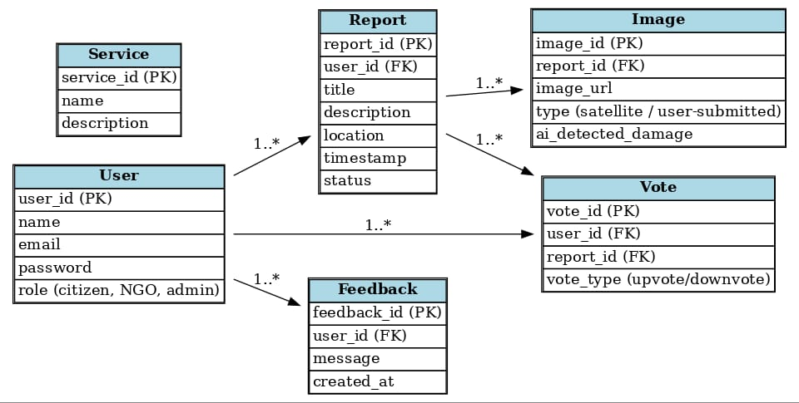
Figure 6 Entity Relationship Diagram

DESIGN

DESCRIPTION OF THE PROPOSED (NEW) SYSTEM

Abstract Language (Data, Process, Role, Rule)
Data: Satellite images (pre/post-war), citizen reports, service availability (electricity, water, healthcare), NGO/government feedback.
Process: AI-based change detection, citizen report ingestion and validation, prioritization via voting, and interactive map visualization.
Role: Citizens (submit reports, vote, feedback), NGOs (review reports, plan interventions), Government (monitor analytics, provide planning data), Admin (manage users, validate content).
Rule: Authentication required, mandatory fields for reports, one vote per user per report, duplicate reports flagged automatically.

Functional Requirements
- Interactive map with damage and service availability layers.
- Citizen reporting with location and image upload.
- Voting and feedback modules with real-time counts.
- NGO/Admin dashboards for validation and planning.
- Authentication and authorization (JWT).

Non-Functional Requirements
- Scalability via cloud deployment.
- Security: encrypted passwords, role-based access control.
- Usability: responsive UI for mobile/desktop.
- Reliability and fault tolerance for map and AI services.

Modeling

PROCESS: Activity & Sequence
The activity and sequence diagrams describe the flow for submission, validation, and publication of citizen reports, as well as the core interactions between the web app, API, database, and NGO/Admin users.

e) ROLE: Use Case
The use case diagram depicts actors (Citizen, NGO, Admin, Government) and their interactions with the system (submit report, vote, review, manage users, and view analytics).

f) CONSTRAINTS / RULE
Key constraints enforced: mandatory fields for report submission, single vote per (user,report) pair, and a finite state machine for report status transitions.

g) SYSTEM ARCHITECTURE, APPLICATION ARCHITECTURE
A three-tier architecture: presentation (React, Leaflet), application (Laravel, REST API), and data (MySQL, AI services). External satellite sources integrate via ETL processes into the AI module.

h) SYSTEM / SOFTWARE SPECIFICATION
- Front-End: React.js, Bootstrap, Leaflet.js
- Back-End: PHP (Laravel), REST APIs
- Database: MySQL
- AI: Python (TensorFlow, OpenCV)

SYSTEM COMPONENTS

Interface / input & output design
The following forms and reports define the primary interfaces.
Form No. | Form Name | Purpose | Main Fields / Elements
Form (1) | Home Screen | Main landing page showing system overview and navigation options | Header , quick links, summary , footer
Form (2) | Citizen Report Form | Submit local need/incident | Title, Description, Location picker, Image upload, Category
Form (3) | Main Map Screen | Entry screen with interactive Sudan map | Layers (Damage/Services), Legend
Form (4) | Login and Register | Allow users to log in or crate an account before using the system | Email, Password, confirm password, Other informations

Form (1) Home Screen:
- The home page displays system highlights and navigation options.
- It gives users quick access to the map, reporting, and analytics dashboards.
- A responsive layout ensures smooth experience on desktop and mobile devices.

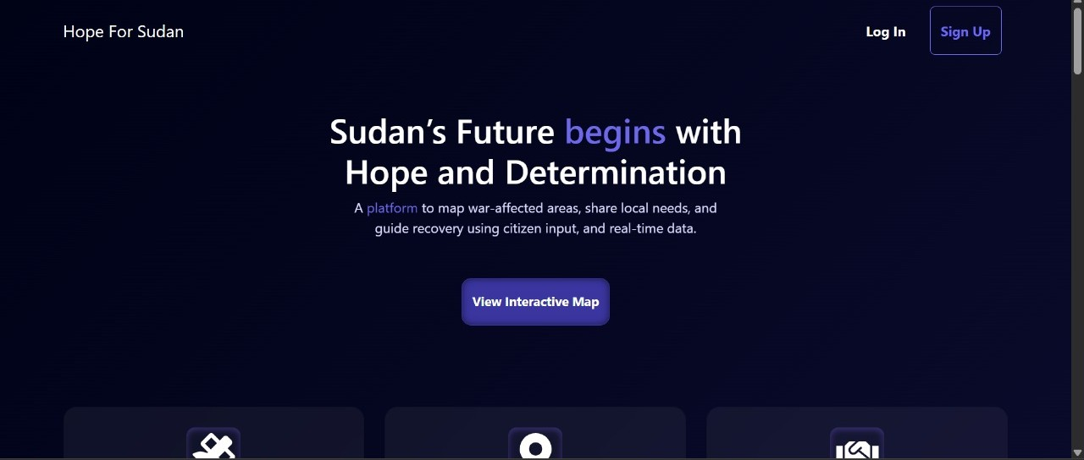
Figure 7 Home Page Screen

Form(2) Citizen Report Form:
- Citizens use this form to report issues or needs in their area.
- They can enter the title, description, location, and upload an image.
- Once submitted, reports go to the admin or NGO for validation.

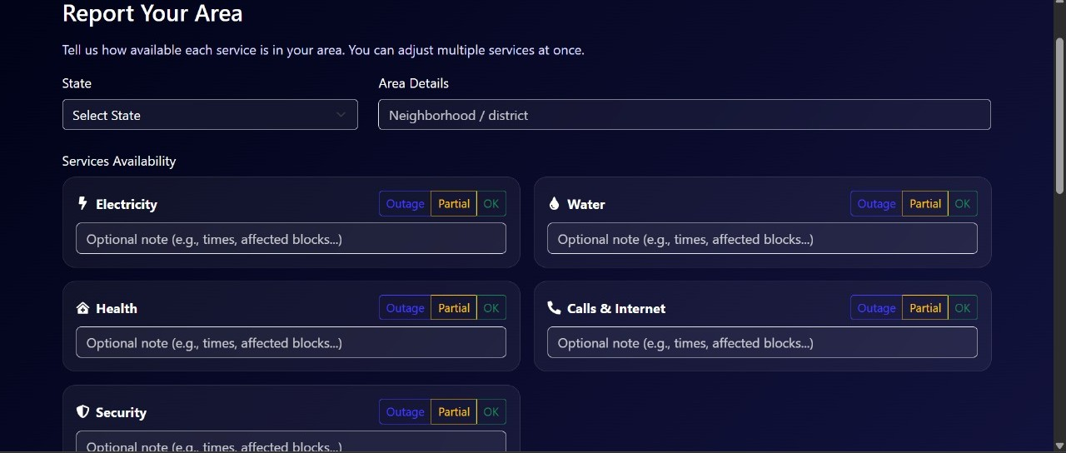
Figure 8 Citizen Report Form
Form(3) Main Map Screen:
- This is the main interface showing the interactive map of Sudan.
- Users can explore service availability layers, view damage zones, and filter reports.
- From here, users can also access the report submission form.
- Left bar controls the map
- Legends shows the legends information

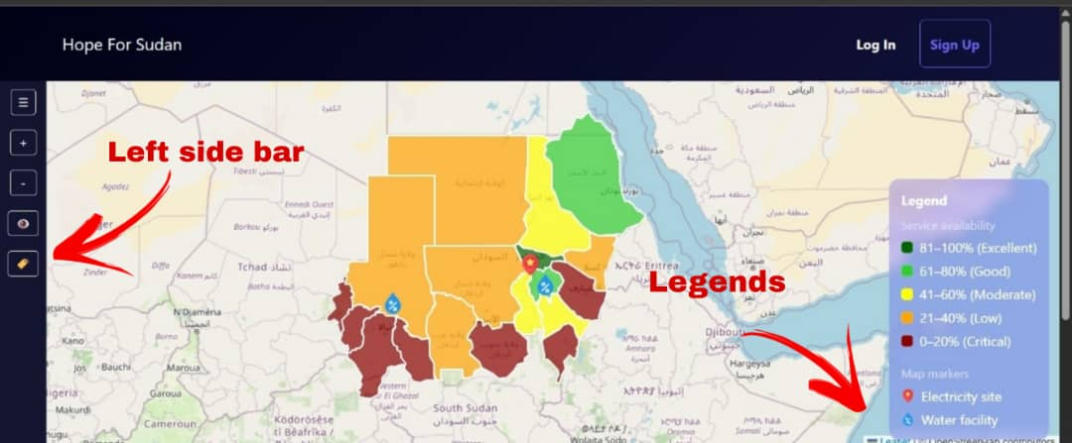
Figure 9 Main Map Screen (1)

- By clicking on the state on the map it shows the Right Side Bar which contains the state details
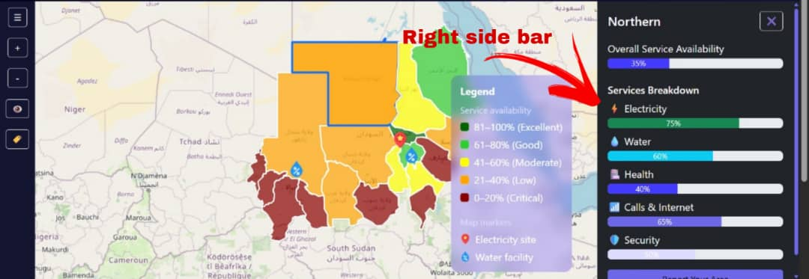
Figure 10 Main Map Screen (2)
Form(4) Login And Register:
- Citizens use this form to report issues or needs in their area.
- They can enter the title, description, location, and upload an image.
- Once submitted, reports go to the admin or NGO for validation.

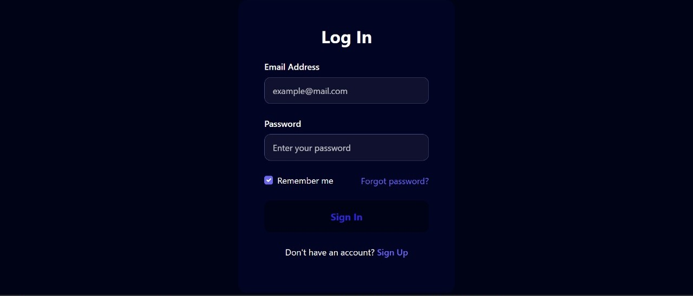
Figure 11 Login and Register

      - Scenario / Order (Storyboard)
1. Home Page: Show Sudan map with service layers and recent reports.
2. Citizen Flow: Login → Submit Report → Confirmation → Visible on Map after approval.
3. Voting Flow: Browse needs → Vote → Rank updates in real time.
4. NGO Flow: Login → Review queue → Approve/Reject → Plan services.
5. Admin Flow: Manage users and roles; monitor system health and logs.

Database Design

PHYSICAL DESIGN (Physical Storage)
- MySQL 8.x with UTF-8 collation.
- Daily backups and point-in-time recovery.
- Indexes on FKs and frequently queried columns (email, status, timestamp).

Database View (Dummy Data) :

Reports :
report_id | user_id | title | description | location | timestamp
1 | 1 | Need #1 | Water/electricity disruption | Khartoum | 2025-09-01 10:00:00
2 | 2 | Need #2 | Water/electricity disruption | Omdurman | 2025-09-02 10:00:00
3 | 3 | Need #3 | Water/electricity disruption | Bahri | 2025-09-03 10:00:00
4 | 4 | Need #4 | Water/electricity disruption | Gezira | 2025-09-04 10:00:00
5 | 5 | Need #5 | Water/electricity disruption | Kassala | 2025-09-05 10:00:00
6 | 6 | Need #6 | Water/electricity disruption | Port Sudan | 2025-09-06 10:00:00
7 | 7 | Need #7 | Water/electricity disruption | Sennar | 2025-09-07 10:00:00
8 | 8 | Need #8 | Water/electricity disruption | Blue Nile | 2025-09-08 10:00:00
9 | 9 | Need #9 | Water/electricity disruption | North Kordofan | 2025-09-09 10:00:00
10 | 10 | Need #10 | Water/electricity disruption | River Nile | 2025-09-10 10:00:00

Tools (Dataset Manipulation Steps)
- Acquire satellite imagery from open repositories (Sentinel/Landsat).
- Preprocess images: geo-alignment, cloud masking (Python/OpenCV/rasterio).
- Run CNN-based change detection (TensorFlow).
- Store damage index per tile in MySQL; expose via REST API.
- Render layers on React/Leaflet map with dynamic filters.

Algorithms (Flow Chart): Optional
Refer to the included flowchart for the single-vote rule and the activity diagram for report lifecycle.

Coding: Page (1–3)
Software used: React.js (UI), Leaflet.js (maps), Laravel (API), MySQL (DB), Python (AI). Chosen for scalability, open-source ecosystems, and strong community support.
Sample Endpoint (Laravel): POST /api/reports → validates input, stores record, returns 201 Created.
Sample AI Pseudocode (Python): load pre/post images → align → CNN change detection → store damage index.

Testing: Page (1–3)
- Unit tests for form validation and API endpoints.
- Integration tests: AI results visible in map layers.
- UAT with pilot users (citizen/NGO): submit report, vote, review.
- Performance tests: p95 API latency < 500ms; map pan/zoom < 200ms.

User manual
Figure (3.2): Main Screen – Interactive map with layers, report button, and filters.
- User name and role displayed in the header after login.
- Map canvas with layers toggle: Damage, Services, Reports.
- Report button opens Citizen Report Form.
- Filters: region, date range, damage level.
- Dashboard link for NGOs/Admin.

